**Questions for Quiz-1**

Q1. **Change the following expression to conditional expression (ternary operator): 3**

if (a>b && a>c)

printf("%d is the largest value", a);

else

{ if (b> a && b >c)

printf("%d is the largest value", b);

else

printf("%d is the largest value", c);

}

**Ans.**

(a>b && a>c)? printf("%d is the largest value", a) : ((b> a && b >c) ? printf("%d is the largest value", b) : printf("%d is the largest value", c));

Give one mark for each correct expression. Give full marks if the whole is correct. They may use the ternary operator in different ways. Please give marks if logic is correct.

Q2. What will be the output? Assume the user input is 5. 1

void main ()

{

int number ;

scanf ("%d", &number );

printf ("%d", number==3);

}

**Ans. 0**

**No partial marks**

Q3. **Find the output of the following code fragment 1**

#include<stdio.h>

void main( )

{

printf("%d", 'B'+1);

}

**Ans. 67**

**No partial marks**

Q4. The following statements are part of a C program in which both the x is integer. What are the values of x in the following? 1

int x=3;

printf(“%d”,x+++2);

**Ans. 5 if they consider the output**

4 if they consider the value of x after the execution is done.

Give full marks if the answer is either of these two. Give 0 for all other answers.

**Q5.**  What will be the output of the following code segment: 1

int x=5;

if(x==3);

printf(“%d”,x+5);

**Ans. 10**

**Give 1 mark for each correct value**

Q6. What is the output of the program when input is 2? 2 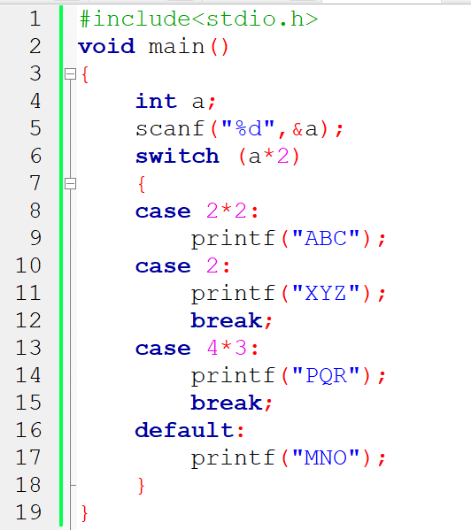

**Ans. ABCXYZ**

**No partial mark**

Q7. What will be printed if the following code segment is executed? 1

int x=2,y=4;

if(x=y)

printf("Hello");

else

printf("Hii");

**Ans. Hello**

**No partial mark**

8. Write the equivalent code segment for the following code segment, using a for loop: 2

int i=5, f=1;

while(i>0)

f*=i--;

**Ans.**

**int f=1;**

**for(int i=5; i>0;i--)**

**f*=i;**

**Give 1 mark if they include the initialization statement f=1 in the for loop with a ,.**

9. Write a code segment (NO NEED TO WRITE FULL PROGRAM) using an infinite while loop, to input a character, check if the character is ‘A’ or not; exit the loop only if the input character is ‘A’. Rewrite the same code segment using an infinite for loop. 3+3

**Part 1:**

**while(1)**

**{**

**ch=getchar();**

**if(ch==’A’)**

**break;**

**}**

**Part 2:**

**for(;;)**

**{**

**ch=getchar();**

**if(ch==’A’)**

**break;**

**}**

10. Point out the error(s) in the following code fragment: [0.5 x 4 =2]

(a) int main()

{

float x, y, z;

printf(“Enter the values :\n”);

scanf(“%.2F%.2F”, &x,&y);

z=(x&gt;y?x:5) ;

return 0;

}

Ans: %F instead of %f

(b) void main()

{

int x=1;

do while( x<10) {

printf(“%d”, x);

x++;}

}

Ans: incorrect use of ‘do while’

(c) void main()

{

int a,b,c,d;

scanf(“%d%d%d”, &a,&b,&c);

d= ab + a*c -b;

printf(“%d”,d);

}

Ans: incorrect expression: ab

(d) void main()

{

int i;

float j;

printf(“Enter 1 or 2 or 3”);

scanf(“%d”, &i);

switch(j)

{

case 1:

break;

case 2:

printf(“%d”, i);

case 3:

printf(“Good”);

default:

printf(“I am in default”);

} }

Ans: float is not allowed in switch